Research Riders Meeting Topics
February 10, 2011 12:00pm
Building 71 Main Conference Room
Call to Order.

Treasurer’s report:

Report from Sandra on current treasury status.
We have one gas cards given to the lucky finders, right ?

Old Business Section:

- Any revisions to last month’s (November’s) minutes? Move to accept
- “Find the Landmark” game is still rolling. James found Dustin’s last one and posted the photo below Jan 31st. So we are down to our last gas card! James – when do we see the next posting?? OK – go get it! (James)

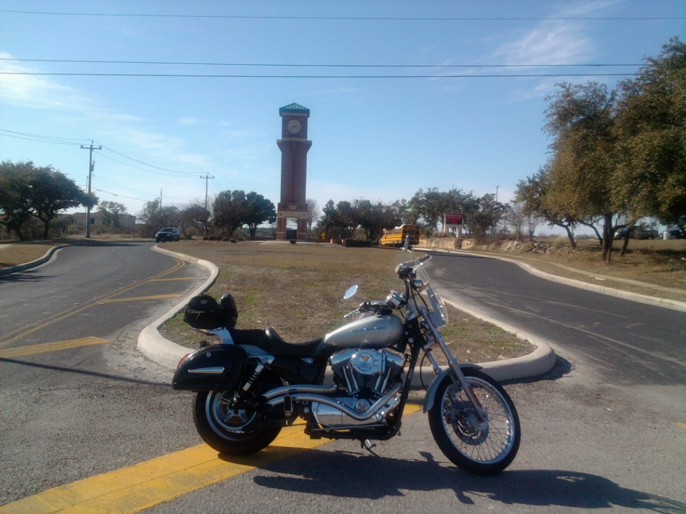

James found Dustin’s Secret Landmark Location on Jan 31

- The idea was presented by Mark to locate some sort of easily accessible web site where group members could post their plans for informal rides and make it known to others in the group, in case some want to meet up to ride together. Let’s make this a formal action item. Mark and Sandra have some good ideas in this area, so they can lead a committee to figure out the best way to do this. OPEN – (Mark / Sandra)
- January Ride – postponed due to the threat of rain and the lack of a big group wanting to go. We’ll reschedule it for this month – see the notes below. (Scott)
- Bike to breakfast – We decided to start it off with the SwRI Cowboy Breakfast (Friday, Feb 25th), then run it every month after that on the first Friday of the month. So add that date to your calendars and we’ll meet up in the Library parking lot and head over to grab some grub. Reminder announcements will be forthcoming. (Scott)
- POLAR BEAR COMPETITION – its going on this month and the weather has been appropriate – 8 riders are in! Started tracking mileage Feb 1 and whoever rides the most miles in the month wins the coveted Polar Bear patch. The Pres threw out a First Week Challenge: Add up your mileage from 12:01am Feb 1 through 11:59 pm Feb 4 (Friday). On Saturday it gets to be a balmy 60 or something, so that’s no fun. Whoever has the most mileage in this period gets a free lunch at the SwRI Cafeteria, day of their choice, and a $10 gas card from the Pres! And the winner was…….(James / Scott)
- The Club website in the RRA website has been updated recently to add more photos and club description – check it out, it looks good. We plan to us this site for all future picture additions since its easy and accessible. (Scott)
http://rra.swri.org/Clubs/ResearchRiders-Motorcycle/ResearchRiders.htm

New Business Section:
- Updates from Publicity / Ride activities in Texas Committee – Mark
- Group Ride for February – let’s do the one we originally set up for January – a loop of about 100 miles through the southside of San Antonio. Leave around 10am and end up at Texas Pride BBQ for lunch. Date? – pick between Feb 19 and Feb 26.

- Long Range planning for the annual multi-day ride. I suggest the weekend of May 27 – 30, encompassing Memorial Day. Friday-Monday. Lets lock in a location so the planning can start. Some suggestions are East Texas/Louisiana, New Mexico, Colorado, New Orleans. Pres thought – Ride to the mountains of the Lincoln Natl Forest in southern NM. Ride up one day, see the aliens in Roswell, then into Cloudcroft. Mountain riding, Ruidoso, Sun Spot. White Sands is nearby, so is Carlsbad Caverns. Almost 600 miles to Cloudcroft.
- Lets organize a group to head to the South Texas Motorcycle Show, March 19-20
http://txbikeshow.com.
- Mark your calendars for Saturday, March 12th for the next St Patrick’s day parade. Who the hell is that?

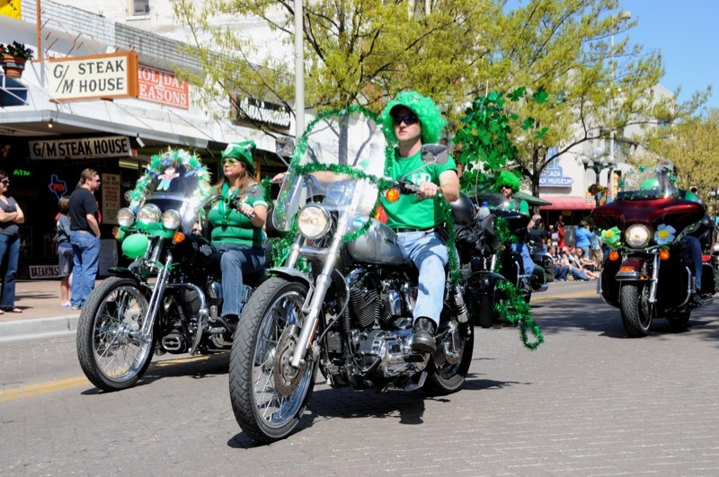

Open Discussion:
- Open topics from the floor

