Research Riders Meeting Topics
January 13, 2011 12:00pm
Building 71 Main Conference Room
Call to Order.

Treasurer’s report:

Report from Sandra on current treasury status and number of members.
Update us on the amount of gas cards given to the lucky finders, and how many we have left to give out.

Old Business Section:

- Any revisions to last month’s (November’s) minutes? Move to accept
- Toys for Tots club donation of $100. All the officers (except Mark who had real work) met the Marines at the cafeteria at noon on Dec 15th to present them the $100 check from the Research Riders. The club supports two charities a year and we have supported the Toys for Tots for several years now. The Marines were very appreciative and we got the opportunity to thank them for their support of our nation. See the photo below. (Scott)

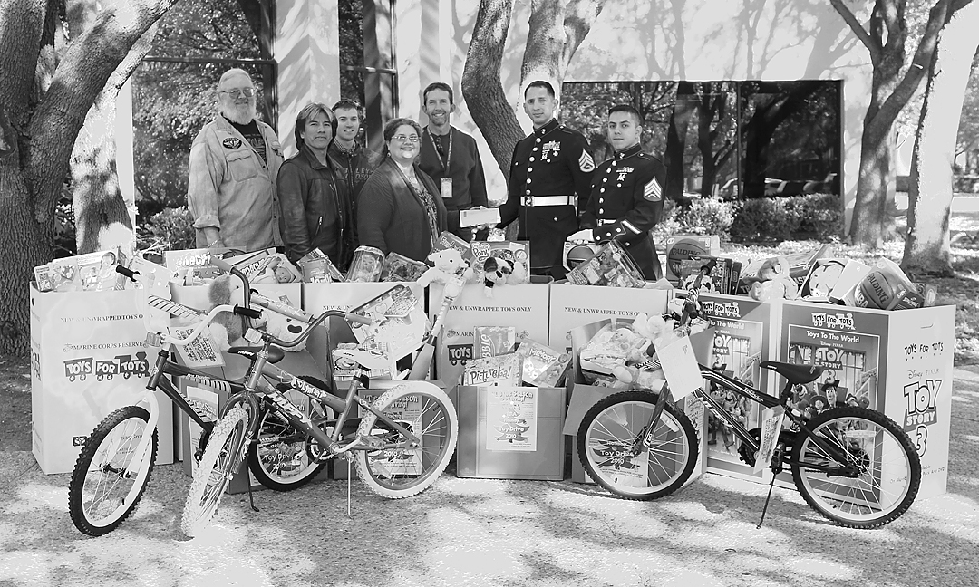
Research Riders Present the Marine Corp with our $100 Donation December 15

- Three riders (Mark, Louie, Scott) represented the Riders at the Blue Knight sponsored Charity Ride for the Mission Road Development Center Dec 11th. This turned out to be a really good ride – there were probably 100 riders of all types from many different groups (Police, Fire Fighters, Air Force, Green Knights) there, a classic car show, bike contest, before-ride breakfast. The parade extended probably 1 mile and all the intersections were blocked by police. The kids at the center were really excited. We should add this event to our agenda every year. (Louie)
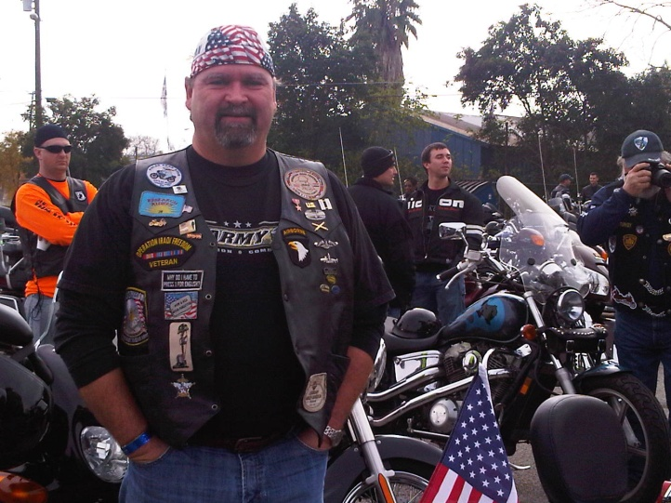 | 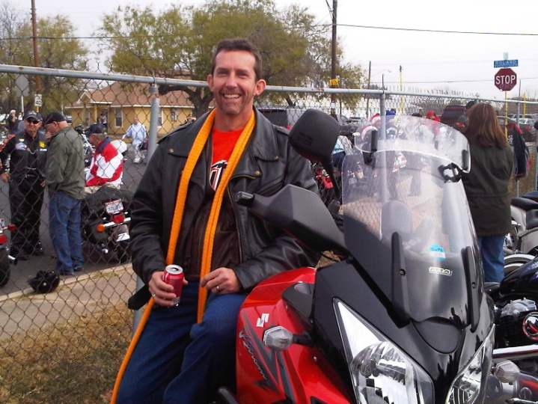

- “Find the Landmark” game is still rolling. No activity since Dustin posted his picture Nov 8th (see below) Two gas cards are still available for the lucky finders. OK – go get it! (Scott)

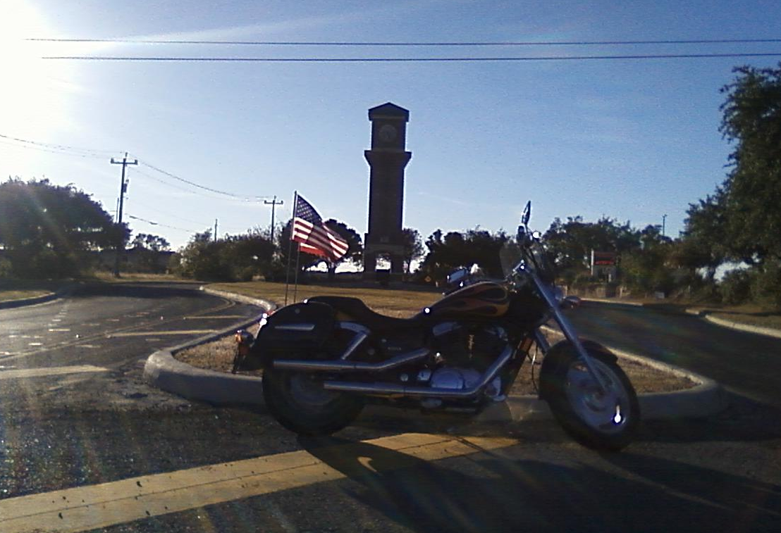
Dustin’s Latest Secret Landmark Location. Posted Nov 8th.

- The idea was presented by Mark to locate some sort of easily accessible web site where group members could post their plans for informal rides and make it known to others in the group, in case some want to meet up to ride together. Let’s make this a formal action item. Mark and Sandra have some good ideas in this area, so they can lead a committee to figure out the best way to do this. OPEN – Mark / Sandra
- December Dinner Meeting – about 18 club members and family attended our dinner meeting at Henry’s Puffy Tacos on Bandera Dec 9th. We had a good time, good food, and club business was held to a minimum….(Scott)
- Survey – its been a couple months since these were handed out -- discuss a summary of the results and comments (James)
- Bike to breakfast – We talked in November about doing this and how often, and the consensus was to start it off with the SwRI Cowboy Breakfast (Friday, Feb 25th), then run it every month after that on the first Friday of the month. So look for that announcement next month. (Scott)

New Business Section:
- POLAR BEAR COMPETITION – we selected the month of February for this event. Start tracking your mileage Feb 1, and whoever rides the most miles in the month wins the coveted Polar Bear patch. Everyone who wants to enter has to give their staring mileage to James. Go for it!
- Updates from Publicity / Ride activities in Texas Committee – Mark
- Group Ride thoughts for January? – thoughts from group. Let pick one, a leader, and a date -- Louis.
  - Ride to Corpus and see the Lexington
  - Hill Country – Hwy 16, Bandera, 336. 337 loop – great scenery and roads.
  - Ride to Fredericksburg and the War in the Pacific Museum & German food
  - Ride to La Grange for the Fly-in (Feb 5th

Open Discussion:
- Open topics from the floor

