Research Riders Meeting Topics
November 18, 2010 12:00pm
Building 71 Main Conference Room

Call to Order.

Treasurer’s report:

Report from Sandra on current treasury status and number of members.
Pass around agenda sheet so folks in attendance can update it as necessary.
Update us on the amount of gas cards given to the lucky finders.

Old Business Section:

- Any revisions to last month’s minutes? Move to accept
- Joint Group Rides discussion:, Ride to Fredericksburg and the War in the Pacific Museum Oct 30th; Ride to La Grange for the Fly-in, Nov 6th. Report: Mark / Sandra
- “Find the Landmark” game is rolling! Mark Griffin found Daniel Garcia’s location – the Hondo Independent School District Admin Building (see the picture below). Mark posted his secret location, and Dustin found his (see the second photo). Dustin has since posted a new one – that’s the last photo. OK – go get it! . Scott

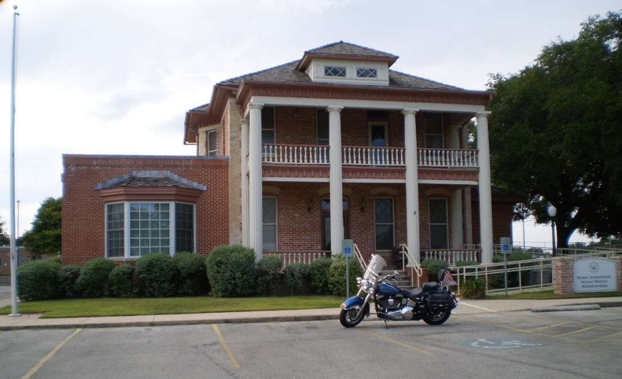
Mark Griffin’s Bike at Daniel Garcia’s landmark in Hondo. Found October 18th.

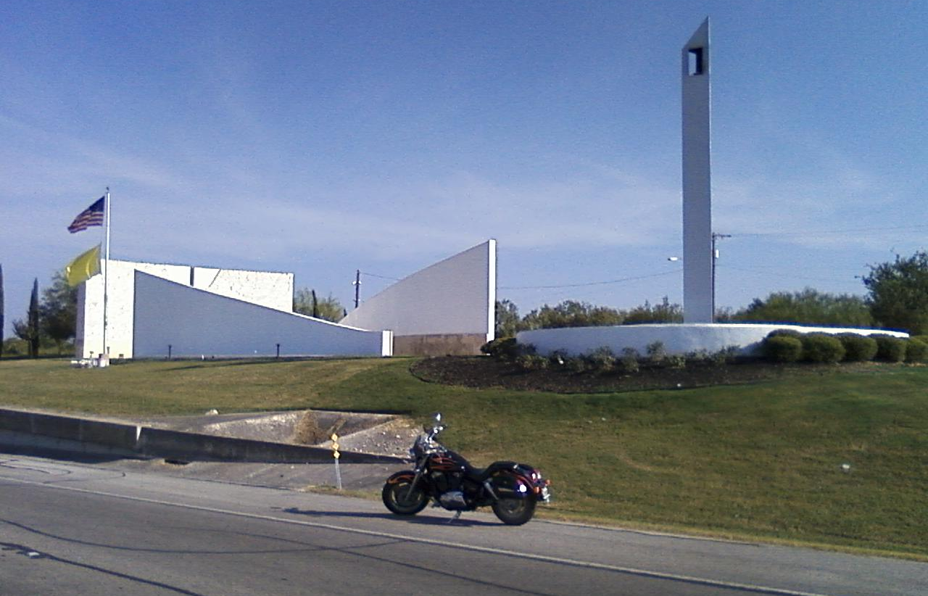
Dustin Noll found Mark’s Landmark October 26th. San Antonio 9/11 Memorial on Hwy. 90 between 410 and 151

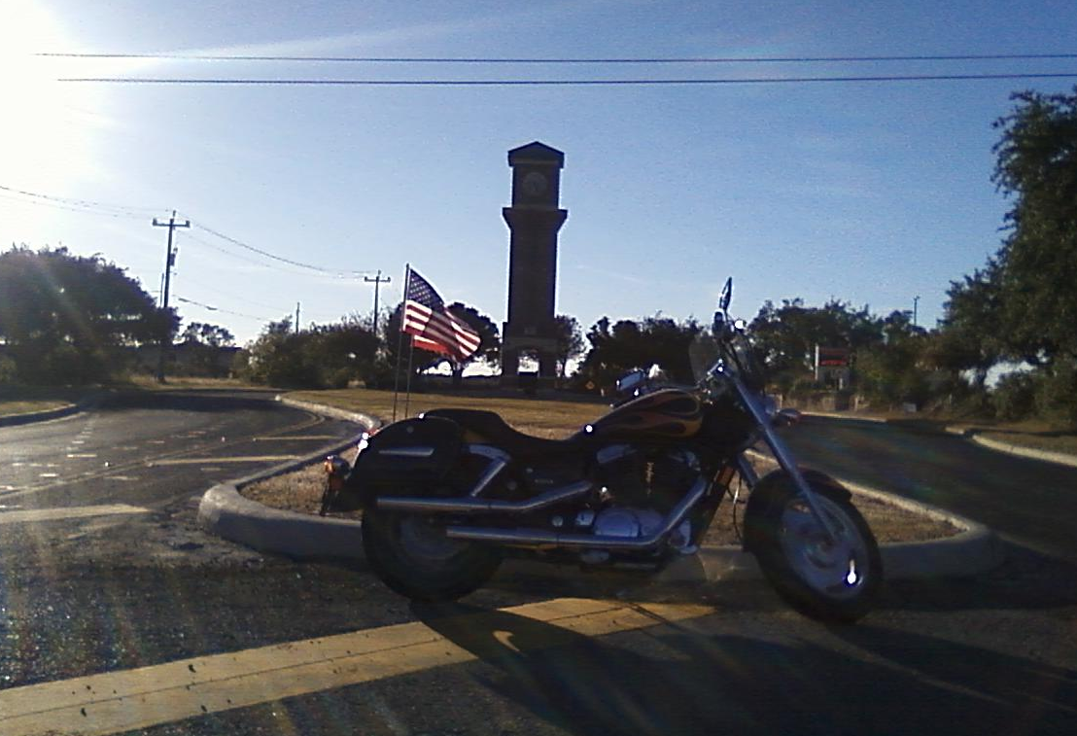
Dustin’s Latest Secret Landmark Location. Posted Nov 8th.

- The idea was presented by Mark to locate some sort of easily accessible web site where group members could post their plans for informal rides and make it known to others in the group, in case some want to meet up to ride together. Let’s make this a formal action item. Mark and Sandra have some good ideas in this area, so they can lead a committee to figure out the best way to do this. OPEN – Mark / Sandra
- Survey – a new one was done this month, and handed out first to folks at the Veteran’s day parade on campus. Everyone else get one and turn them into James so we can make sure we orient the club activities the way the membership wants.
- VETERANS DAY PARADE – Nov 11th at SwRI. – a great success! Our own Mark Griffin was the parade leader, and we had 35 riders make the event. Everything went real smooth and it was an honor to remember our veterans. See the pictures below.
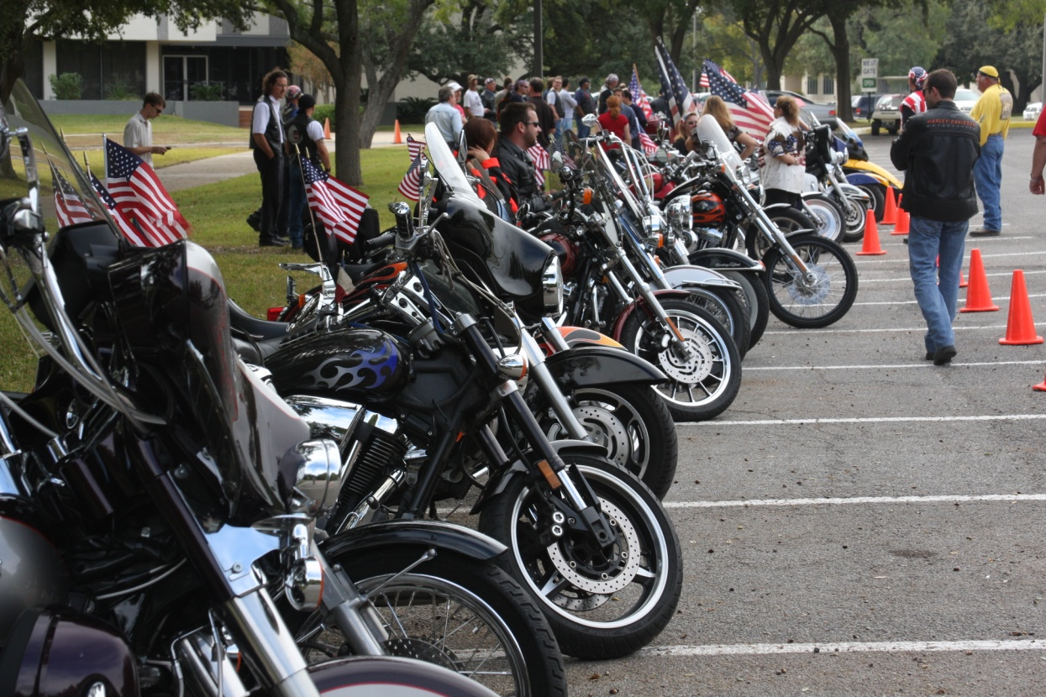

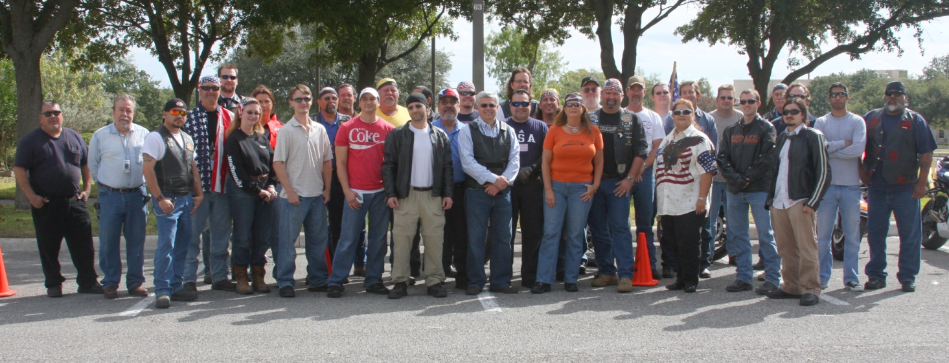

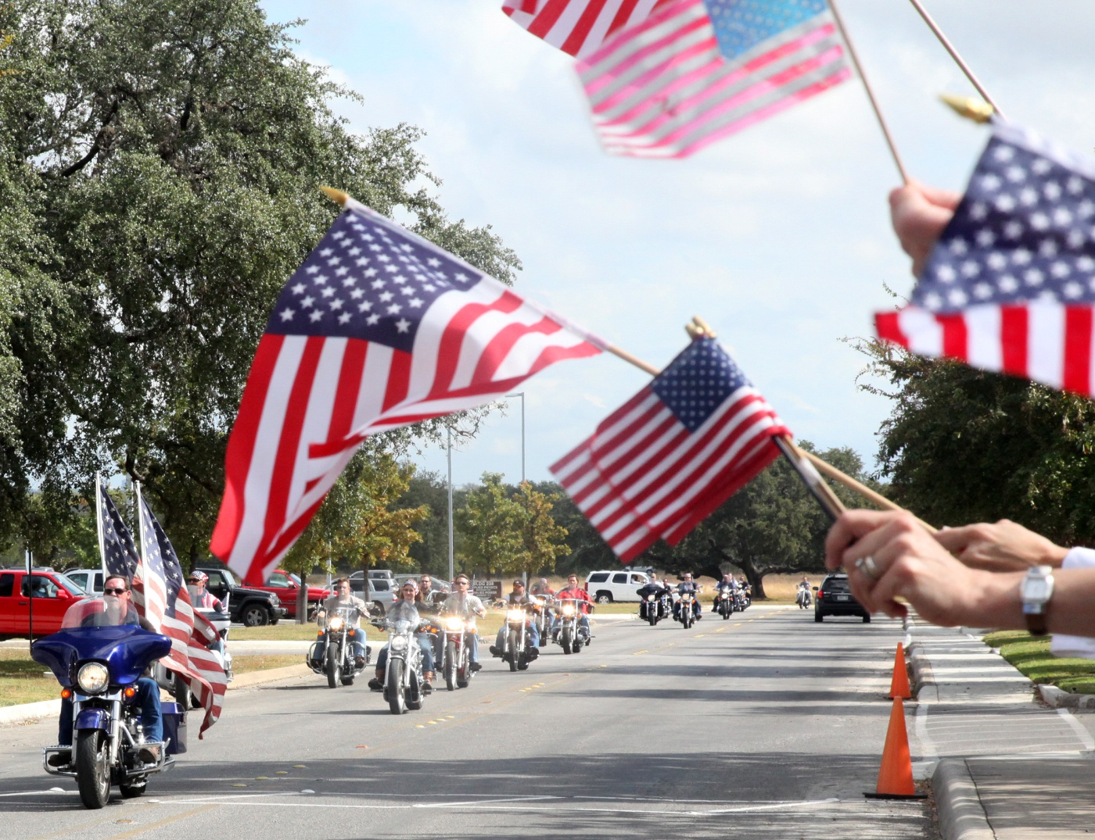
- Happy Times Notice – the write-up Mark did about our annual Picnic Ride and Games Oct 2nd was the lead article in the November 2010 Happy Times. Also passed out to the whole membership. Great article and great press for the group.
New Business Section:
- Bike to breakfast – do we want to do this as a club, and if so, how often? LETS PICK A DAY and start this thing off.
- Toys for Tots Charity ride in December – we have done this every year for the past 5-6 years. Mark to update the planning for this one. Dates and Locations.
- Updates from Publicity / Ride activities in Texas Committee – Mark
- Ride thoughts for November? – thoughts from group. Let pick one, a leader, and a date -- Louis.
  - Ride to Corpus and see the Lexington
  - Thanksgiving day ride – Friday after Thanksgiving – Patrick
  - Fredericksburg & German food -- Karol
- Review / Confirmation of Research Riders Announcements – are we good with these, and who takes responsibility to make sure the info gets to each location:
  - Global e-mail announcements about our monthly meetings, out a few days early.
  - Club Section in the Happy Times – we can provide JoLyn monthly info about upcoming events and she will add that in to the Happy Times
  - Update / modify the RRA website page regularly to reflect new upcoming events (an add in photos from past events, and update the description about what the club does)

Open Discussion:

- Open topics from the floor

