Research Riders Meeting Topics
October 14, 2010 12:00pm
Building 71 Upstairs Front Conference Room

Call to Order.

Treasurer’s report:

Report from Sandra on current treasury status, and number of members.
Plus -- dues are due!

Old Business Section:

- Any revisions to last month’s minutes? Move to accept
- Annual Picnic, Ride to Medina Lake area, and Motorcycle Games Report: Mark / James

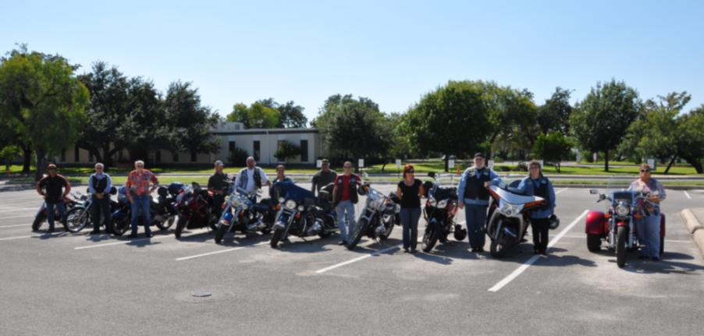
- “Find the Landmark” game is rolling! Daniel Garcia found Dustin Noll’s secret place last month, and the new one is posted below. Congrats Daniel, you get the latest gas card. Scott
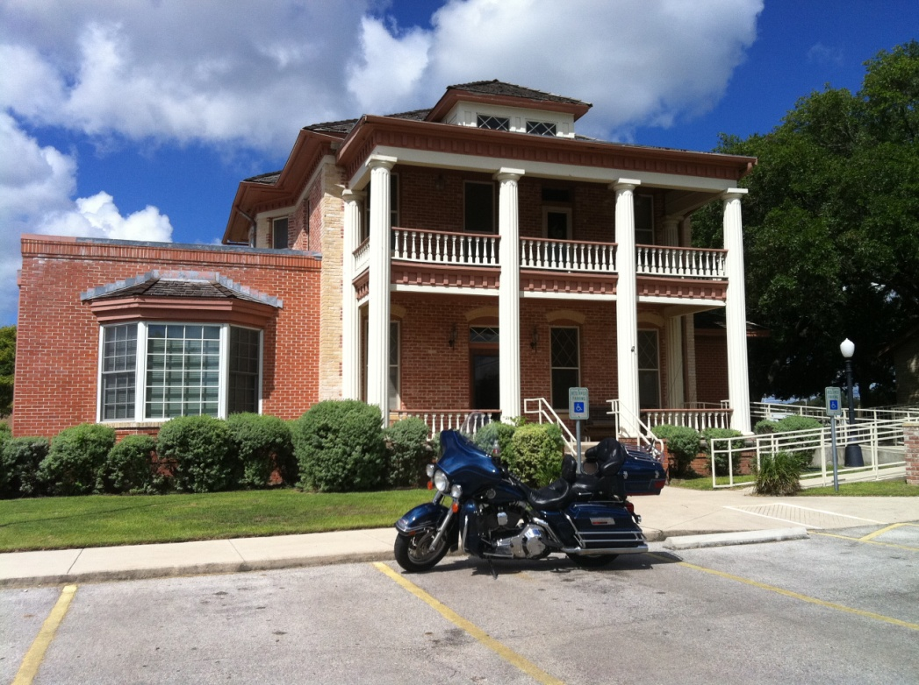

- Next Ride: Suggestions from last meeting include a ride to Fredericksburg are, see the Nimitz museum, partake in some German food & drink. Karol volunteered to take the lead here – lets pick a date.
- The idea was presented by Mark to locate some sort of easily accessible web site where group members could post their plans for informal rides and make it known to others in the group, in case some want to meet up to ride together. Let’s make this a formal action item. Mark and Sandra have some good ideas in this area, so they can lead a committee to figure out the best way to do this.
- Survey – we did one 4 years ago – polling the club membership to find out basically what they wanted out of the club, and what activities they would like see done. Is it time for another survey? If so, Scott and the officers can reformulate one, and send it out again. Need input from the floor on this.
- Updated Research Riders Calendar for quick discussion – Louie.
New Business Section:
- VETRANS DAY PARADE – Nov 11th at SwRI. Craig Witherow will again be setting this up, with help from the riders. We will do the mile loop around campus, like we did last year. This was a great event and we really got great feedback from it, so we want to make sure we have a great turnout again this year! Thursday, Nov 11th. Bring you flags!
- Ride thoughts for November? – hear from the group. do we want to do an overnight club camping ride? Load up the bikes, head to some good spot, set up camp, head back the next day? A Saturday / Sunday thing? The fall is coming – a good time. Enchanted rock was mentioned last month as a good potential spot.
- Bike to breakfast – do we want to do this as a club, and if so, how often?
- Updates from Publicity / Ride activities in Texas Committee – Mark

Open Discussion:

- Patrick Keller got hit – how is he doing?
- Open topics from the floor

